Database Lab 07 :

**Exercise 01:**

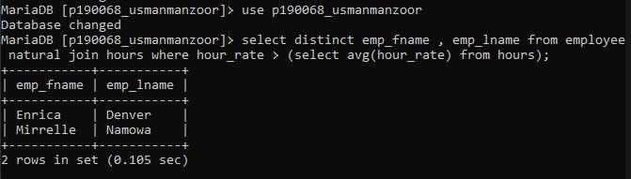

**Exercise 02:**

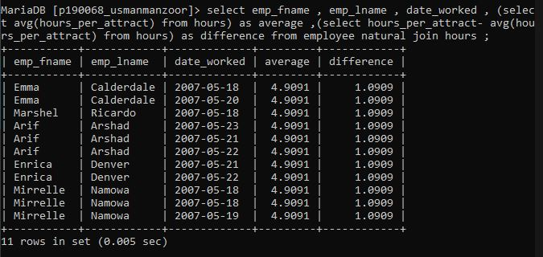

**Exercise 03:**

